E-Commerce Website

Stationery Store



By

Sudharshan Rakhonde

Abstract

Electronic Commerce is process of doing business through computer networks. A person sitting on his chair in front of a computer can access all the facilities of the Internet to buy or sell the products.

Unlike traditional commerce that is carried out physically with effort of a person to go & get products, ecommerce has made it easier for human to reduce physical work and to save time.    E-Commerce which was started in early 1990’s has taken a great leap in the world of computers, but the fact that has hindered the growth of e-commerce is security. Security is the challenge facing e-commerce today & there is still a lot of advancement made in the field of security.

The main advantage of e-commerce over traditional commerce is the user can browse online shops, compare prices and order merchandise sitting at home on their PC.

For increasing the use of e-commerce in developing countries the B2B e-commerce is implemented for improving access to global markets for firms in developing countries. For a developing country advancement in the field of e-commerce is essential. The research strategy shows the importance of the e-commerce in developing countries for business applications.

Acknowledgement

In the present world of competition there is a race of existence in which those are having will to come forward succeed. Project is like a bridge between theoretical and practical working. With this willing we joined this particular project. First of all, we would like to thank the supreme power the Almighty God who is obviously the one has always guided me to work on the right path of life. Without his grace this project could not become a reality.

We would like to express my profound gratitude towards many individuals, as without their kind support, it would not be possible for me to complete this project report. We would like extend my sincere thanks to my guide, who gave me the golden opportunity in enhancing my hidden capabilities. Unfortunately, we addressed several difficulties in coordinating the activities of the project but We are highly indebted to Mr. Rajeev Kumar Sahu for their guidance and constant supervision, as Well as for providing necessary information regarding the project and also for their support in completing the project.

We would also like to express my gratitude towards my parents and subject teacher for their kind co-operation and encouragement as they helped me a lot in completion of this at last, We end up by thanking all who helped me in finalizing the project within the limited time frame.

INDEX

|  |  |  |
| --- | --- | --- |
| Sr. No. | Title | Page No. |
| 1 | Abstract | 2 |
| 2 | Acknowledgement | 3 |
| 3 | Introduction | 5 |
| 4 | Project Description | 6 |
| 5 | Design and Development Environment | 7 |
| 6 | Design and Implement od e-commerce website | 8 |
| 7 | Non-Functional Requirements | 12 |
| 8 | Conclusion | 12 |
| 9 | Reference | 13 |

**INTRODUCTION**

E-commerce is fast gaining ground as an accepted and used business paradigm. More and more business houses are implementing web sites providing functionality for performing commercial transactions over the web. It is reasonable to say that the process of shopping on the web is becoming common place.

The objective of this project is to develop a general purpose e-commerce store where any kind of all stationery product can be bought from the comfort of home through the Internet. However, for implementation purposes, this paper will deal with an online shopping for baby product.

An online store is a virtual store on the Internet where customers can browse the catalog and select products of interest. The selected items may be collected in a shopping cart. At checkout time, the items in the shopping cart will be presented as an order. At that time, more information will be needed to complete the transaction. Usually, the customer will be asked to fill or select a billing address, a shipping address, a shipping option, and payment information.

**PROJECT DESCRIPTION**

1. User can view, search and compare available products.
2. User can view and purchase products.
3. User can excess add option and can view everything.
   1. User can add product, edit product, update and remove product.
   2. Can access users some product information.
   3. User can ship order to user based on order placed by sending confirmation mail.
4. User can see analytics of products.
   1. User can see the product demands in a year.
   2. User can see the product sold in year
5. Its show the graphical analytics to user.
   1. User can see dynamically changes of data.

**DESIGN AND DEVELOPMENT ENVIRONMENT**

* HTML5
* CSS3
* Bootstrap (Grid & Frameworks)
* JavaScript
* Visual Studio code
* Commerce API
* React
* JSX
* Rechart
* JSON
* Material UI

**DESIGN AND IMPLEMENTATION OF**

**E-COMMERCE SITE**

1. **Home Page**

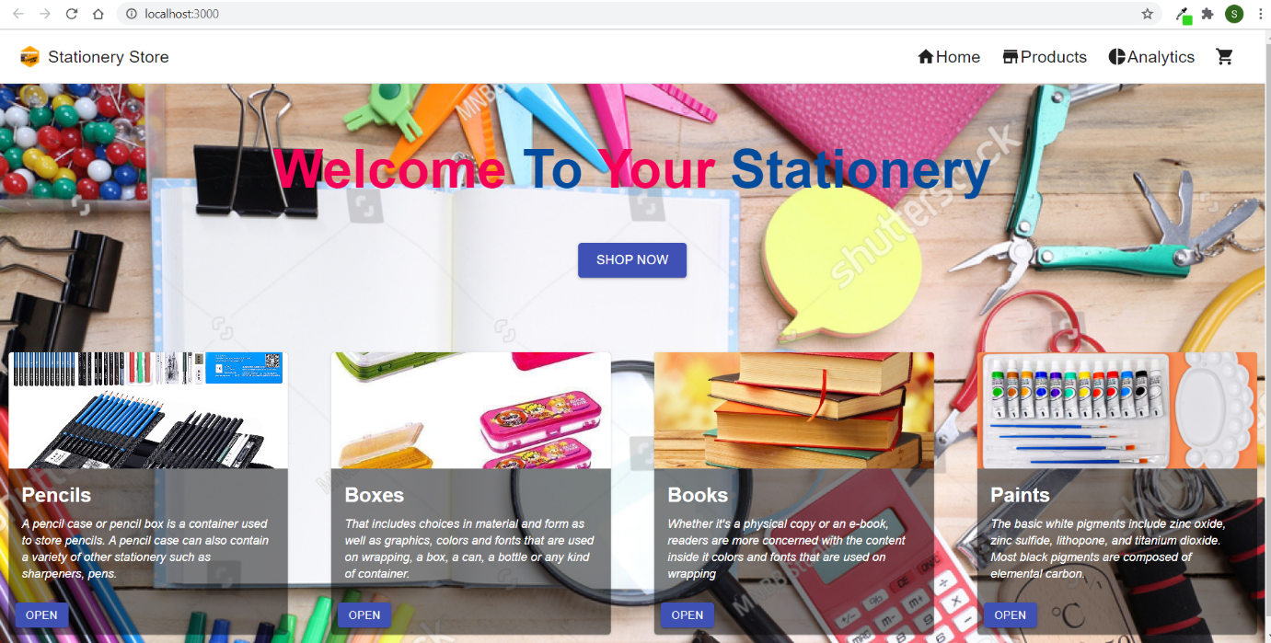

1. **Product Page**

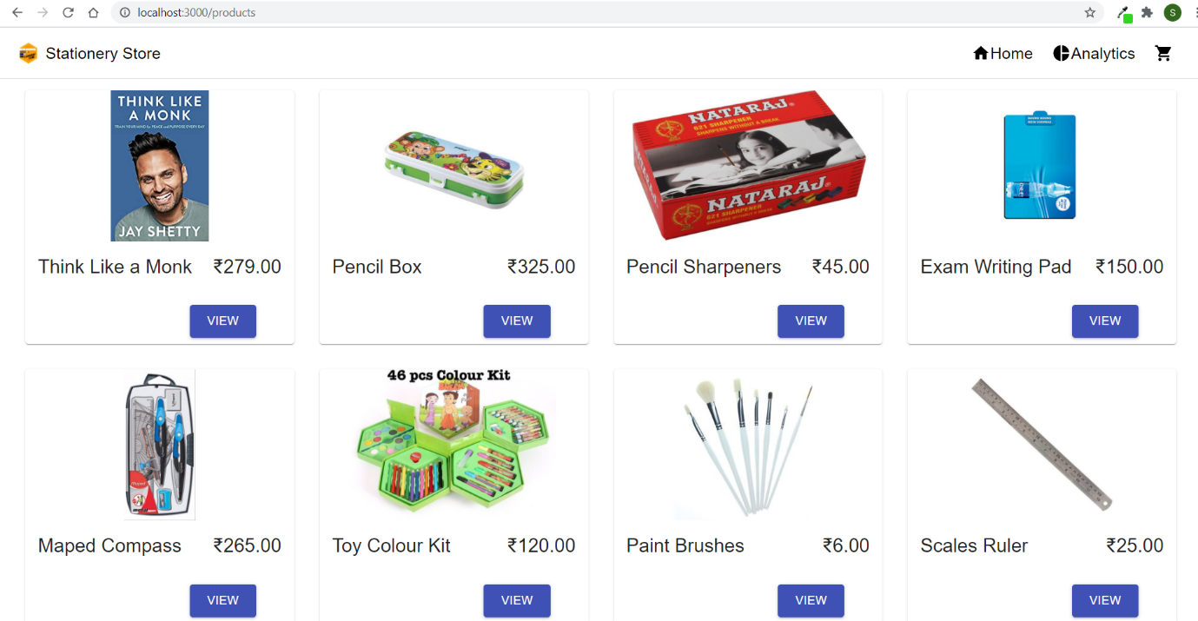

1. **Product Details Page**

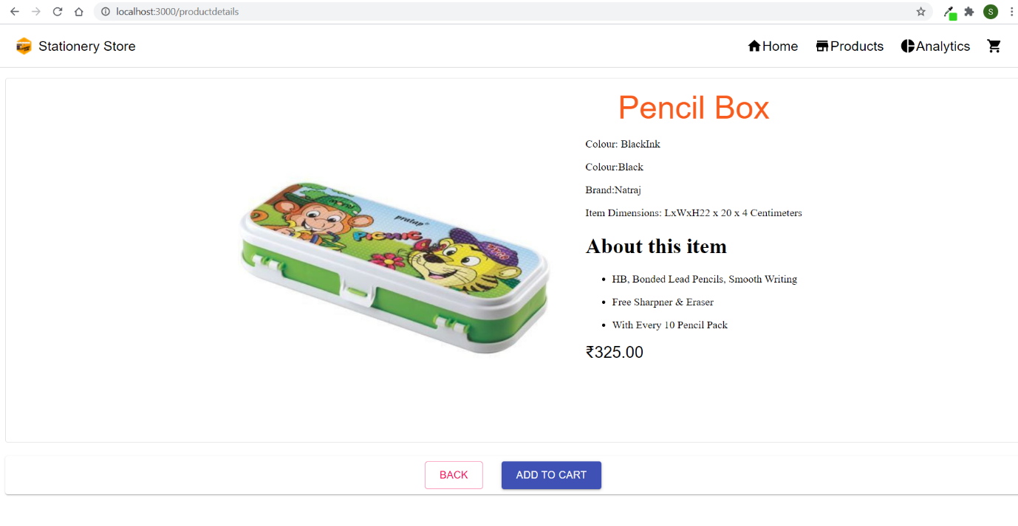

1. **Analytics Page**

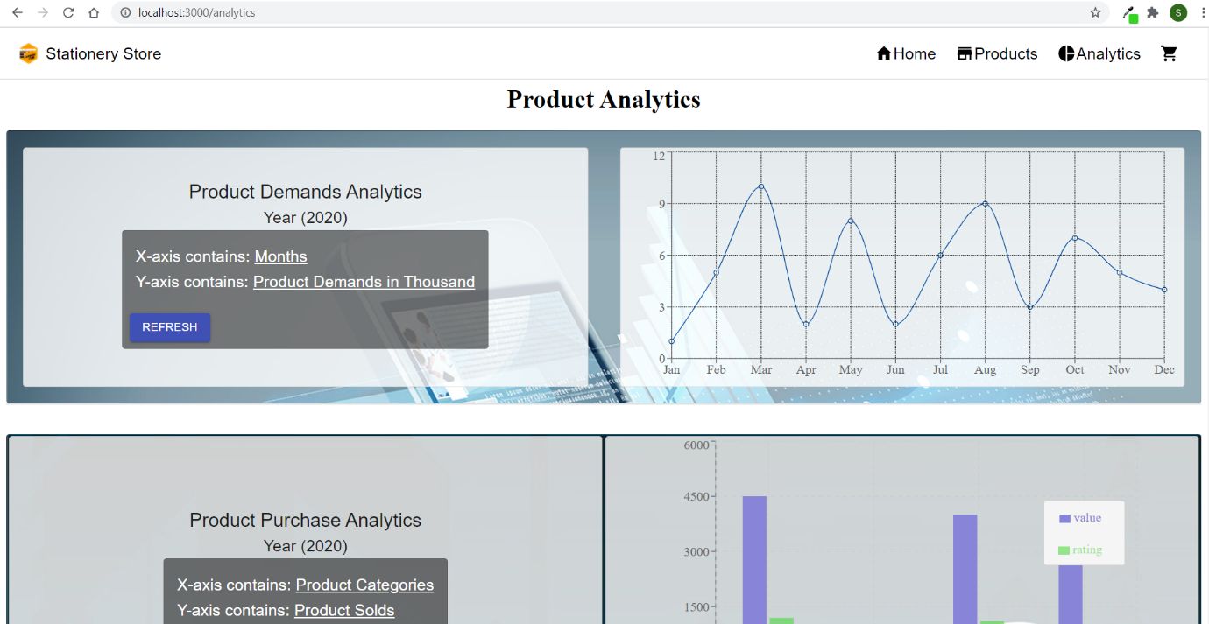

1. **Cart Page**

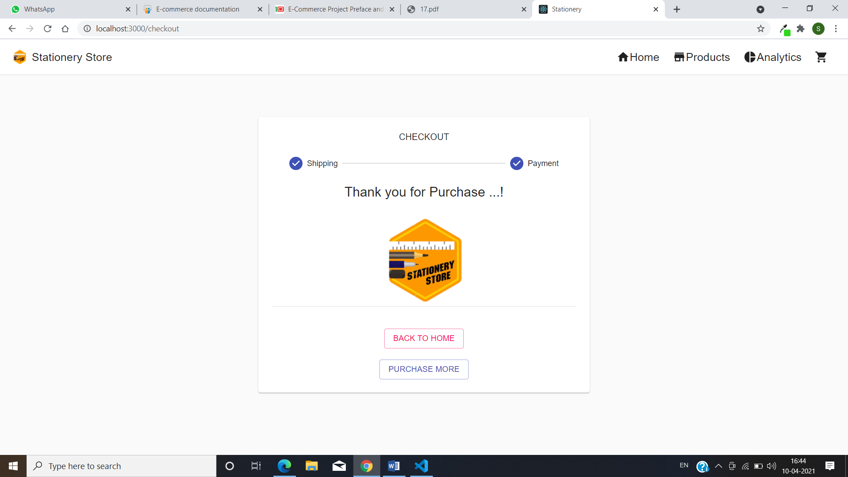

1. **Shipping Page**

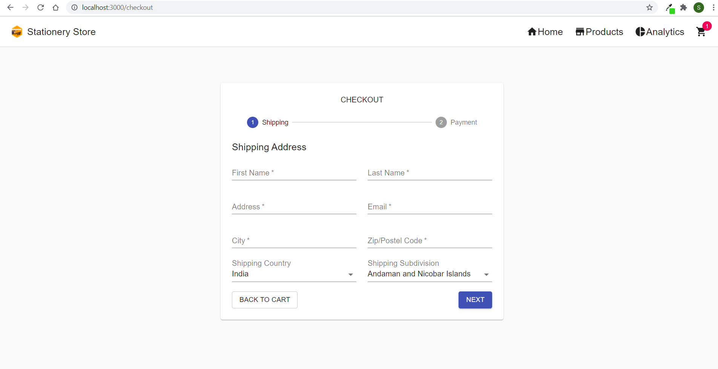

1. **Payment Page**

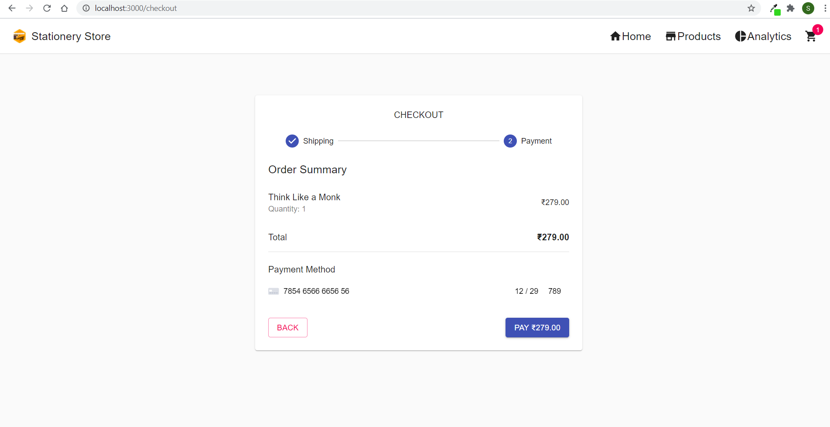

1. **Confirmation Page**

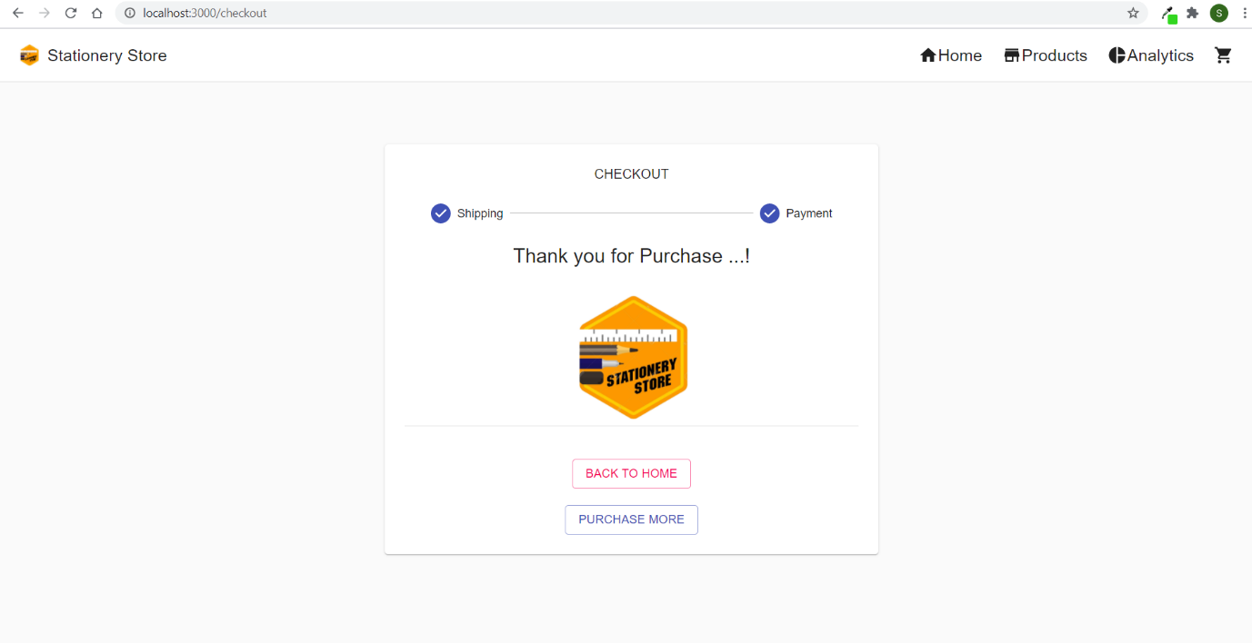

**NON-FUNCTIONAL REQUIREMENTS**

• Security Pages of the website must be access in the way they were included files shall not be accessed outside of their parent file.

• Efficiency and Maintainability Page loads should be returned and formatted in a timely fashion depending on the request being made.

**CONCLUSION:**

The Internet has become a major resource in modern business, thus electronic shopping has gained significance not only from the entrepreneur’s but also from the customer’s point of view. For the entrepreneur, electronic shopping generates new business opportunities and for the customer, it makes comparative shopping possible. As per a survey, most consumers of online stores are impulsive and usually make a decision to stay on a site within the first few seconds. “Website design is like a shop interior. If the shop looks poor or like hundreds of other shops the customer is most likely to skip to the other site. Hence we have designed the project to provide the user with easy navigation, retrieval of data and necessary feedback as much as possible. In this project, the user is provided with an e-commerce web site that can be used to buy all types baby products online. In this project the ‘add to cart’ functionality made by raw JavaScript without using any plugin and bKash payment system is not included properly in this project because to complete bKash payment system we require a particular payment gateway

**REFERENCES:**

* [**https://reactjs.org**](https://reactjs.org)
* [**https://material-ui.com**](https://material-ui.com)
* [**https://recharts.org/en-US/**](https://recharts.org/en-US/)
* [**https://commercejs.com/**](https://commercejs.com/)
* [**https://reactjs.org/docs/hooks-intro.html**](https://reactjs.org/docs/hooks-intro.html)
* [**https://www.w3schools.com/react/**](https://www.w3schools.com/react/)
* [**https://www.javascript.com/**](https://www.javascript.com/)
* [**https://getbootstrap.com/**](https://getbootstrap.com/)